Cucurbit Downy Mildew in North Carolina

Cucurbit downy mildew (CDM) has been reported on cucumbers near Wilson, North Carolina. To keep track of where downy mildew has been reported please visit the following website: http://cdm.ipmpipe.org/

Cucurbit growers are urged to consider spraying preventative applications for downy mildew and thoroughly scout for the disease. Cucumber growers in particular are strongly recommended to initiate a downy mildew protection program. Growers near the outbreak are advised to be particularly diligent for management and scouting of the disease.

Over the past growing seasons, our research has found spray programs containing Ranman (2.75 floz/A) to offer the best protection from this disease. Presidio (4 floz/A) and Previcur Flex (1.2 pt/A) are also effective, however, we caution growers to rely upon these materials solely as our trial results from 2009 – 2011 for Previcur Flex and 2011 for Presidio were not as favorable as in past seasons in our cucumber CDM trials. These materials should be rotated/tank mixed with protectant fungicides containing mancozeb or chlorothalonil. Fungicide applications should be initiated prior to disease development and applied on a 7-10 day schedule. Growers will realize optimal disease control when applications are made in at least 20 GPA of water and crop coverage is good. Cultural practices, such as avoiding low lying fields and excessive overhead irrigation, will also suppress disease development. There are some differences in the susceptibility of cucumber cultivars to CDM. If you have any questions along those lines, please feel free to contact us.

Cucurbit downy mildew can be recognized initially by small yellow spots on the upper surface of the lower leaves (Figure 1). When humidity is high (particularly early in the morning) blue/gray sporulation can be found on the underside of the leaves (Figure 2). If you have any further questions or think you have cucurbit downy mildew present in your field, please let us know. We will continue to update you on the progress of this disease. This is an unusually early finding of this disease this far north.
Thanks
Steve Rideout, Ph.D.
Associate Professor of Plant Pathology
Director
Virginia Tech – Eastern Shore AREC
srideout@vt.edu
(757) 414-0724; ext. 17
FOLLOW US ON FACEBOOK FOR UPDATES & ALERTS: www.facebook.com/vtesarecpp
Figure 1.

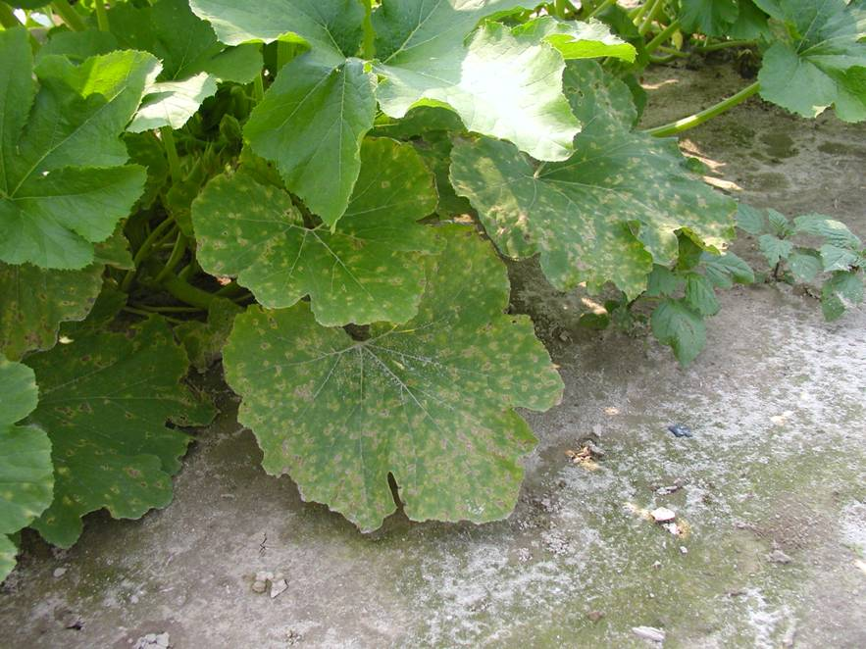

Figure 2.

