Cucurbit Downy Mildew in North Carolina

Cucurbit downy mildew (CDM) has been reported on cucumbers in North Carolina. The closest reported threat to Virginia is from Wilson Co., NC. To keep track of where downy mildew has been reported please visit the following website: http://www.ces.ncsu.edu/depts/pp/cucurbit/

This current outbreak is an unusually early reporting of this disease in the Mid-Atlantic region. Cucurbit growers are urged to consider spraying preventative applications for downy mildew and thoroughly scout for the disease. Cucumber growers in particular are strongly recommended to initiate a downy mildew protection program. Due to the location of this outbreak and persistent rainy conditions, growers near the outbreak are advised to be particularly diligent for management and scouting of the disease.

Over the past growing seasons, our research has found spray programs containing Presidio (4 floz/A) and Ranman (2.75 floz/A) to offer the best protection from this disease. Previcur Flex (1.2 pt/A) is also effective, however, we caution growers to rely upon this material solely as our trial results from 2009 were not as favorable as in past seasons. These materials should be rotated/tank mixed with protectant fungicides containing mancozeb or chlorothalonil. Fungicide applications should be initiated prior to disease development and applied on a 7-10 day schedule. Growers will realize optimal disease control when applications are made in at least 20 GPA of water and crop coverage is good. Cultural practices, such as avoiding low lying fields and excessive overhead irrigation, will also suppress disease development.

Cucurbit downy mildew can be recognized initially by small yellow spots on the upper surface of the lower leaves (Figure 1). When humidity is high (particularly early in the morning) blue/gray sporulation can be found on the underside of the leaves (Figure 2). If you have any further questions or think you have cucurbit downy mildew present in your field, please let us know. We will continue to update you on the progress of this disease.

Figure 1.

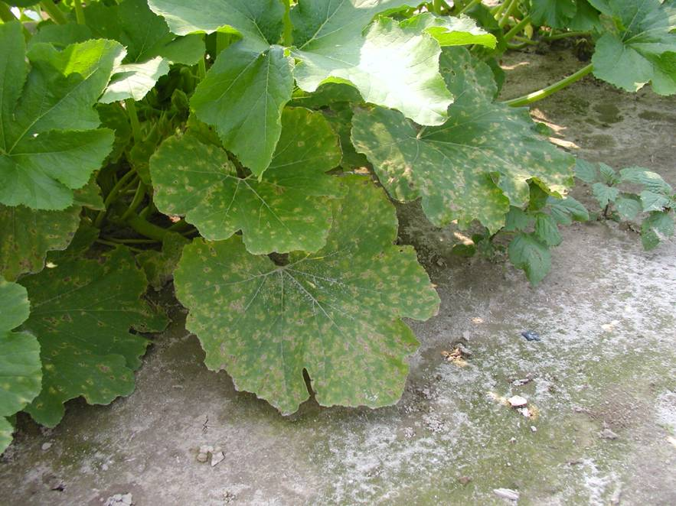

Figure 2.

