Cucurbit Downy Mildew in North Carolina and New Jersey

Cucurbit downy mildew (CDM) has been reported on cucumbers in North Carolina and Vineland, New Jersey. The closest reported threats to Virginia are from Hertford & Wilson Co., NC. To keep track of where downy mildew has been reported please visit the following website: http://cdm.ipmpipe.org/

Cucurbit growers are urged to consider spraying preventative applications for downy mildew and thoroughly scout for the disease. Cucumber growers in particular are strongly recommended to initiate a downy mildew protection program. Growers near the outbreak are advised to be particularly diligent for management and scouting of the disease.

Over the past growing seasons, our research has found spray programs containing Presidio (4 floz/A) and Ranman (2.75 floz/A) to offer the best protection from this disease. Previcur Flex (1.2 pt/A) is also effective, however, we caution growers to rely upon this material solely as our trial results from 2009 and 2010 were not as favorable as in past seasons. These materials should be rotated/tank mixed with protectant fungicides containing mancozeb or chlorothalonil. Fungicide applications should be initiated prior to disease development and applied on a 7-10 day schedule. Growers will realize optimal disease control when applications are made in at least 20 GPA of water and crop coverage is good. Cultural practices, such as avoiding low lying fields and excessive overhead irrigation, will also suppress disease development.

Cucurbit downy mildew can be recognized initially by small yellow spots on the upper surface of the lower leaves (Figure 1). When humidity is high (particularly early in the morning) blue/gray sporulation can be found on the underside of the leaves (Figure 2). If you have any further questions or think you have cucurbit downy mildew present in your field, please let us know. We will continue to update you on the progress of this disease.

Thanks
Steve Rideout, Ph.D.
Associate Professor of Plant Pathology
Interim Associate Director
Virginia Tech – Eastern Shore AREC
srideout@vt.edu
(757) 414-0724; ext. 17
FOLLOW US ON FACEBOOK FOR UPDATES & ALERTS: www.facebook.com/vtesarecpp
Figure 1.

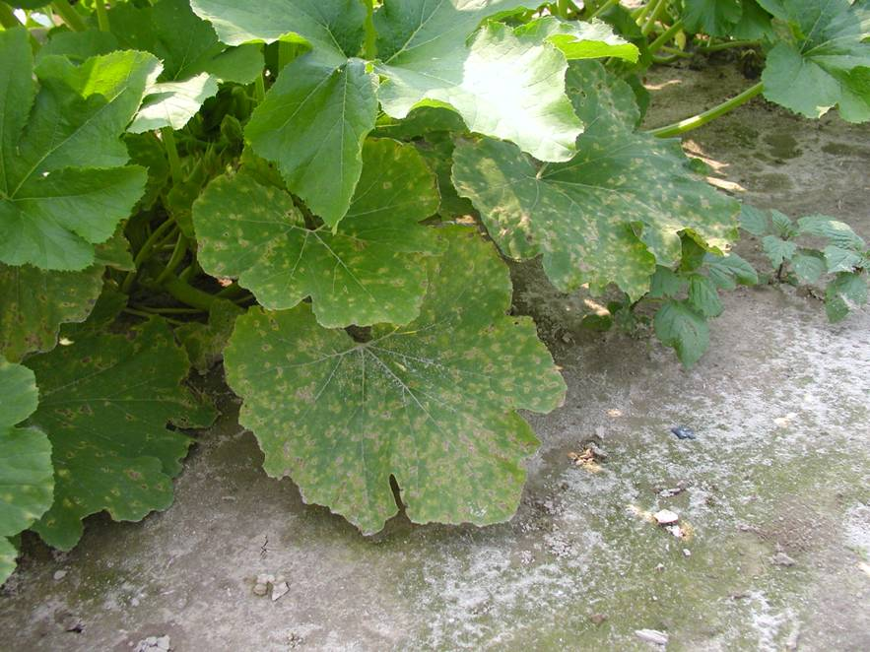

Figure 2.

