Virginia Potato Disease Advisory – 2012
Sponsored by the Virginia Irish Potato Board
April 19

This is the first Virginia Potato Disease Advisory for 2012. We want to thank the Virginia Irish Potato Board for funding the network of sensors and our weekly reports. Thanks to the VIPB and all the participating producers! In addition to our disease predictions, see below for a description of Rhizoctonia of potato.

To date, drier than normal conditions have not been conducive for late blight development, therefore Late Blight Disease Severity Values (DSV) have not been accumulated for any location. P-Day values for early blight development are NOT exceeding thresholds for fungicide treatment at all locations. There are no current reports of late blight within our region. At this time, no fungicide applications are recommended. Please check back next week for an updated report since (hopefully) the forecast is for rain over the coming days.

Late Blight Disease Severity Values (DSV) accumulated to date:
Location | Total DSV | Spray Recommendation
Horntown | 0 | None Recommended
New Church | 0 | None Recommended
Painter | 0 | None Recommended
Birdsnest | 0 | None Recommended
Seaview | 0 | None Recommended
Kiptopeke | 0 | None Recommended

Early Blight P-Days accumulated to date:
Location | Total P-Days | Spray Recommendation
Horntown | 45 | None Recommended
New Church | 45 | None Recommended
Painter | 47 | None Recommended
Birdsnest | 162 | None Recommended
Seaview | 178 | None Recommended
Kiptopeke | 182 | None Recommended

Weekly Potato Disease Summary

Rhizoctonia of Potato

Causal Organism: Rhizoctonia of potato is caused by the soilborne fungus Rhizoctonia solani. The fungus can overwinter in the soil on plant debris or on infected tubers. The pathogen can be an issue from planting until harvest. Seed pieces and emerging stolons may be infected by Rhizoctonia prior to emergence. Damping-off can be caused on emerged seedlings under severe infections and favorable conditions. Tubers and stolons can be damaged by the pathogen later in the growing season. Disease is favored by moderate soil temperatures (50 - 70F) with excessive rainfall or irrigation. The fungus can infect and damage most crop plants planted on the Eastern Shore of Virginia, particularly in the seedling stage.

Symptomology: Poor and non-uniform emergence can result from early infections. Infected potato shoots can be girdled at the soil surface and exhibit a sunken blackish lesion (Figure 1). Similar lesions can be found belowground on stolons later in the growing season, this phase of the disease is known as black scurf (Figure 2). Starch and water translocation can be disturbed in these damaged plants. An increase of aerial, green tubers forming at/above the soil surface has been observed in infected plants. Infected tubers show dark brown-black masses that are small in size, these tuber lesions are actually sclerotia of the fungus attacked to the tuber surface (Figure 3). These masses resemble soil particles clinging to the tuber, however, they cannot be removed with washing.

Control: Use certified seed pieces to ensure that you are not transmitting Rhizoctonia. Burying plant debris deep in the soil after harvest will help reduce inoculum in the soil. Crop rotation to corn, cereal or grass crops will help reduce disease levels. Avoid overirrgation and planting in areas that stay wet. Promote timely emergence, the longer the shoots are in the soil the more susceptible they are to this pathogen. The use of an in-furrow application of Quadris or Moncut will reduce early season infections and ensure a quicker emergence. As always, follow pesticide labels for rates and usage. Finally, harvesting tubers in a timely fashion after vine kill will reduce the possibility of further tuber damage.

Figure 1.

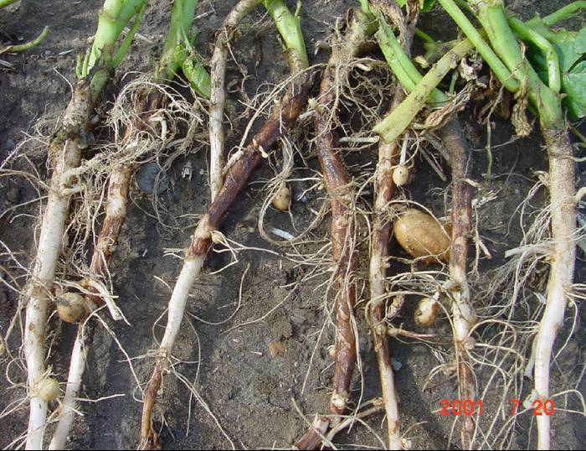

Figure 2.

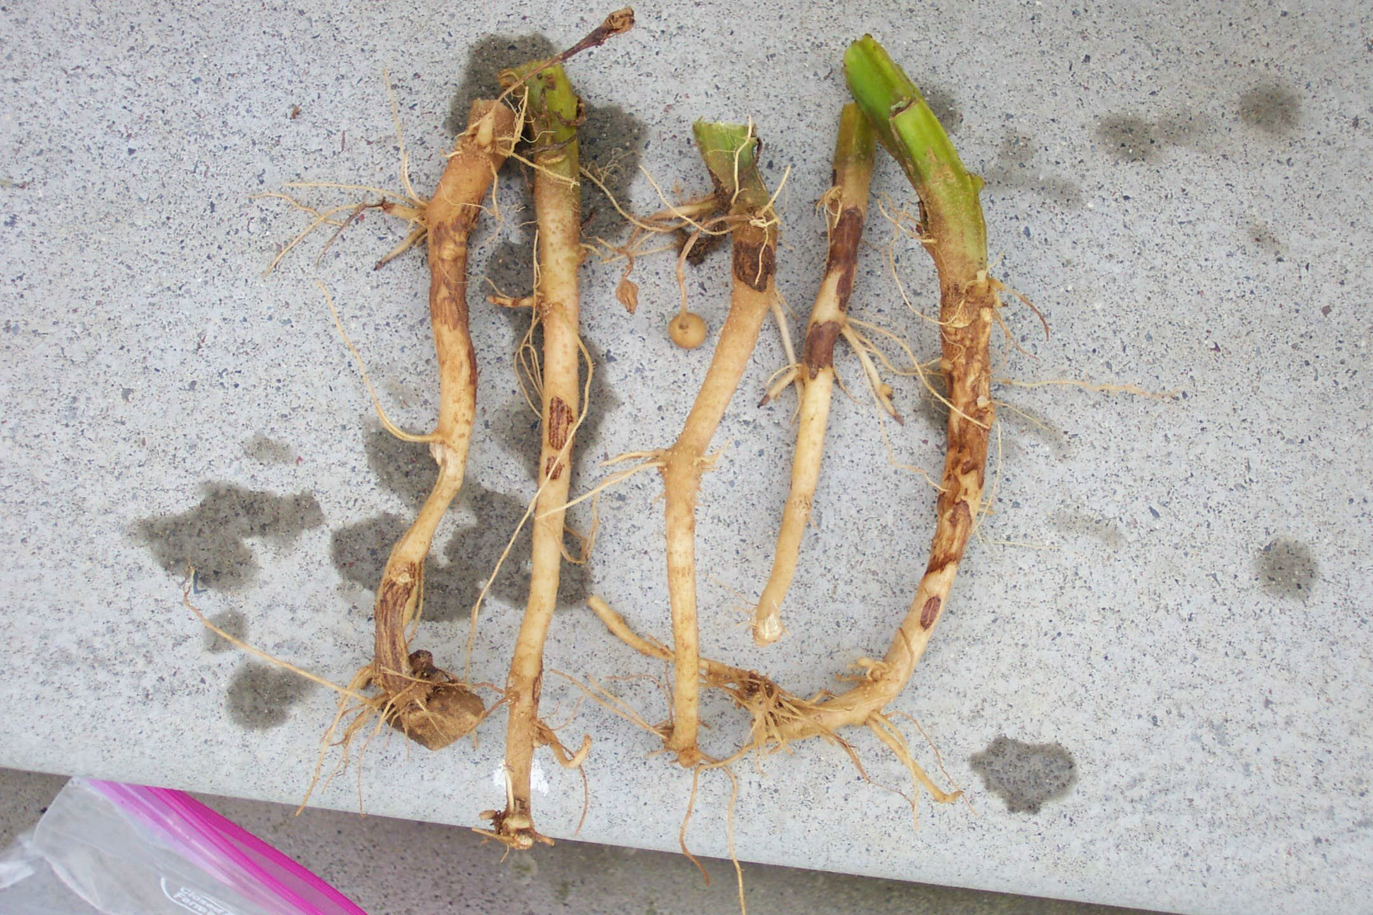

Figure 3.

