Virginia Potato Disease Advisory – 2013
Sponsored by the Virginia Irish Potato Board
June 14, 2013

This is the seventh Virginia Potato Disease Advisory for 2013. We want to thank the Virginia Irish Potato Board for funding the network of sensors and our weekly reports. Thanks to the VIPB and all the participating producers! In addition to our disease predictions, see below for pictures of early blight on potato.

Conditions have led to accumulation of Late Blight Disease Severity Values (DSV) over this past week. We exceeded the threshold of 18 DSVs to trigger a preventative spray at ALL locations. We have not observed late blight on either tomato or potato in Virginia to date. You can track where late blight has been reported in the United States by visiting www.usablight.org. Currently, areas in Florida are the only locations reporting late blight. However, there is a recent report of late blight in a tomato greenhouse operation in Berkeley Spring, WV and in western Tennessee. I would recommend a preventative fungicide application (such as mancozeb or chlorothalonil) at ALL locations on the Eastern Shore of Virginia if you have not applied a fungicide within the last two weeks. In addition, growers are urged to thoroughly scout their field for the disease. If you have any suspicious samples please let us know.

P-Day values for early blight development are exceeding thresholds for fungicide treatment at all locations. Preventative fungicide applications targeting early blight are recommended, although we have not observed early blight in our crop to date. Please check back next week for an updated report.

Late Blight Disease Severity Values (DSV) accumulated to date:
Location | Total DSV | Spray Recommendation
Horntown | 46 | Preventative Recommended
New Church | 34 | Preventative Recommended
Painter | 40 | Preventative Recommended
Birdsnest | 35 | Preventative Recommended
Seaview | 51 | Preventative Recommended
Kiptopeke | 41 | Preventative Recommended

Early Blight P-Days accumulated to date:
Location | Total P-Days | Spray Recommendation
Horntown | 413 | Preventative Recommended
New Church | 409 | Preventative Recommended
Painter | 423 | Preventative Recommended
Birdsnest | 412 | Preventative Recommended
Seaview | 434 | Preventative Recommended
Kiptopeke | 436 | Preventative Recommended

Weekly Potato Disease Summary
Early Blight of Potato
Causal Organism: Early blight of potato is caused by the fungus Alternaria solani. The fungus can overwinter in the soil on plant debris or on infected tubers. Early blight of potato occurs most years on the Eastern Shore of Virginia, generally late in the growing season when conditions favoring the disease persist. Plants that have entered the reproductive stages are more susceptible to early blight than those in vegetative stages. Disease is favored by moderate temperatures (75-80F) with rainfall or dews leading to high leaf moisture (humid). The early blight pathogen can also parasitize tomatoes and eggplants. The weeds horsenettle and nightshade are also hosts.

Symptomology: Infected potato leaves show ‘target spot’ lesions with concentric rings (Figure 1). These infections generally occur on the older leaves of the plant closest to the ground (Figure 2). Older lesions may exhibit a leathery appearance, however, the rings are the most characteristic symptom. Tuber infections show dark (brown-black) lesions that are small in size and irregular in shape, these tuber lesions generally are sunken in appearance (Figure 3). In severe infections, defoliation can occur if appropriate disease control measures are not employed.

Control: Use certified seed pieces to ensure that you are not transmitting early blight. Crop rotation with non-hosts for at least 2 years will help reduce damage. Burying plant debris deep in the soil after harvest will help reduce inoculum in the soil. Certain cultivars have exhibited tolerance to early blight. Avoid overirrgation. Prior to disease appearance, growers should utilize a protectant fungicide (ie. chlorothalonil or mancozeb) once sprays are either deemed necessary by the VPDA. Super Tin/Agri Tin and Polyram are also suitable protectants. Systemic fungicides should be used for disease suppression once early blight has been discovered in your fields. Systemic fungicides recommended for early blight control include: Endura, Fontelis, Gem, Headline, Quadris, Reason, Revus Top, and Tanos. Care should be taken to avoid programs that rely solely on strobilurin fungicides (FRAC Code 11) as resistant strains may develop. As always, follow pesticide labels for rates and usage.

Figure 1.
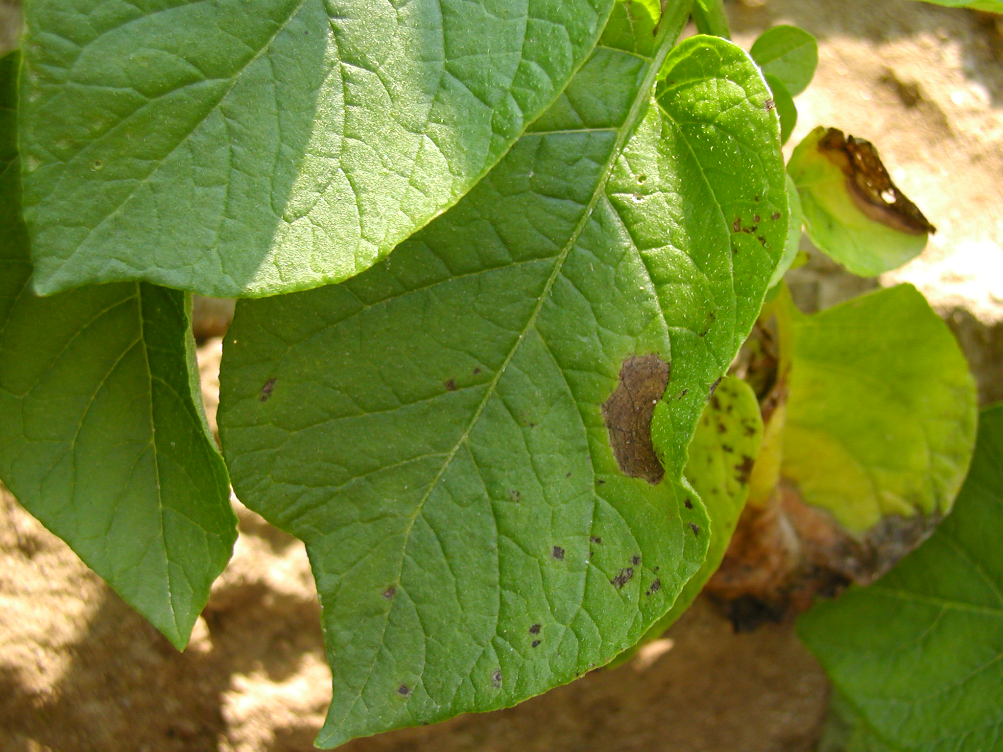

Figure 2.
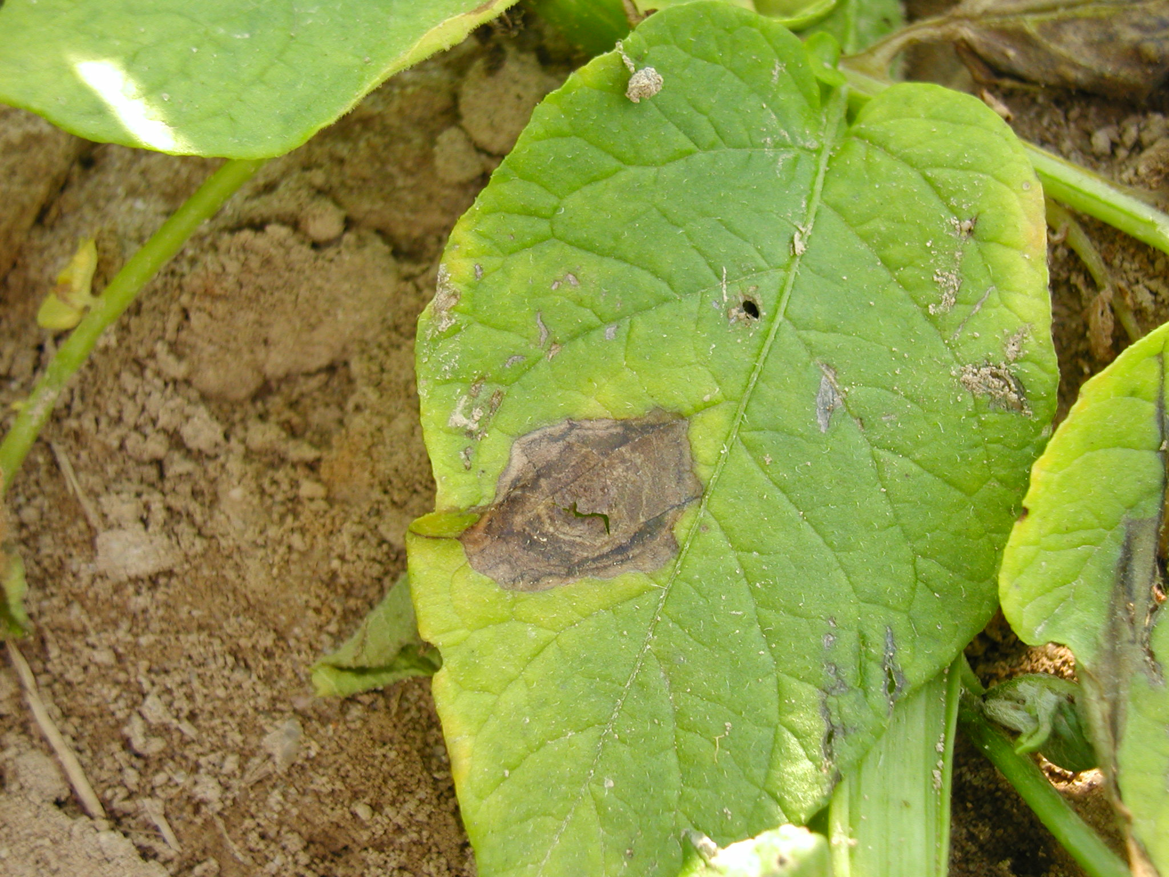

Figure 3.
