Virginia Potato Disease Advisory – 2012
Sponsored by the Virginia Irish Potato Board
May 10

This is the fourth Virginia Potato Disease Advisory for 2012. We want to thank the Virginia Irish Potato Board for funding the network of sensors and our weekly reports. Thanks to the VIPB and all the participating producers! In addition to our disease predictions, see below for a description of early blight of potato.

Potato late blight has been confirmed in a commercial potato field in Camden County, NC. At this time we are still gathering information on the outbreak to ascertain the likelihood of spread, fungicide sensitivities, and source. This is still an active source and should be considered a threat to potato and tomato crops in SE Virginia and the Eastern Shore. To date, recent rainfall has led to some late blight DSV accumulations, however, they are not exceeding thresholds. We still have not found late blight in Virginia or any other areas in the Mid-Atlantic besides the source in NC. Regardless of DSVs, I am recommending an application of a protectant fungicide at this time for potato AND tomato crops on the Eastern Shore and other parts of Eastern VA. Past research has indicated that chlorothalonil (Bravo and other generics) is the most efficacious protectant against late blight. Growers are strongly recommended to scout their fields thoroughly and contact us should you see any suspicious plants.

P-Day values for early blight development are exceeding thresholds for fungicide treatment at the Birdsnest, Seaview, and Kiptopeke locations. No early blight has been found on the ESV to date. At this time, protectant fungicide applications for early blight are recommended at these three locations. Protectants utilized for late blight control will offer similar protection from early blight Please check back next week for an updated report.

Late Blight Disease Severity Values (DSV) accumulated to date:
Location | Total DSV | Spray Recommendation
Horntown | 8 | Protectant Recommended
New Church | 13 | Protectant Recommended
Painter | 13 | Protectant Recommended
Birdsnest | 13 | Protectant Recommended
Seaview | 15 | Protectant Recommended
Kiptopeke | 9 | Protectant Recommended

Early Blight P-Days accumulated to date:
Location | Total P-Days | Spray Recommendation
Horntown | 196 | None Recommended
New Church | 186 | None Recommended
Painter | 188 | None Recommended
Birdsnest | 303 | Protectant Recommended
Seaview | 329 | Protectant Recommended
Kiptopeke | 336 | Protectant Recommended

Weekly Potato Disease Summary
Early Blight of Potato
Causal Organism: Early blight of potato is caused by the fungus Alternaria solani. The fungus can overwinter in the soil on plant debris or on infected tubers. Early blight of potato occurs most years on the Eastern Shore of Virginia, generally late in the growing season when conditions favoring the disease persist. Plants that have entered the reproductive stages are more susceptible to early blight than those in vegetative stages. Disease is favored by moderate temperatures (75-80F) with rainfall or dews leading to high leaf moisture (humid). The early blight pathogen can also parasitize tomatoes and eggplants. The weeds horsenettle and nightshade are also hosts.

Symptomology: Infected potato leaves show ‘target spot’ lesions with concentric rings (Figure 1). These infections generally occur on the older leaves of the plant closest to the ground (Figure 2). Older lesions may exhibit a leathery appearance, however, the rings are the most characteristic symptom. Tuber infections show dark (brown-black) lesions that are small in size and irregular in shape, these tuber lesions generally are sunken in appearance (Figure 3). In severe infections, defoliation can occur if appropriate disease control measures are not employed.

Control: Use certified seed pieces to ensure that you are not transmitting early blight. Crop rotation with non-hosts for at least 2 years will help reduce damage. Burying plant debris deep in the soil after harvest will help reduce inoculum in the soil. Certain cultivars have exhibited tolerance to early blight. Avoid overirrgation. Prior to disease appearance, growers should utilize a protectant fungicide (ie. chlorothalonil or mancozeb) once sprays are either deemed necessary by the VPDA. Super Tin/Agri Tin and Polyram are also suitable protectants. Systemic fungicides should be used for disease suppression once early blight has been discovered in your fields. Systemic fungicides recommended for early blight control include: Endura, Gem, Headline, Quadris, Reason, Revus Top, and Tanos. Care should be taken to avoid programs that rely solely on strobilurin fungicides (FRAC Code 11) as resistant strains may develop. As always, follow pesticide labels for rates and usage.

Figure 1.
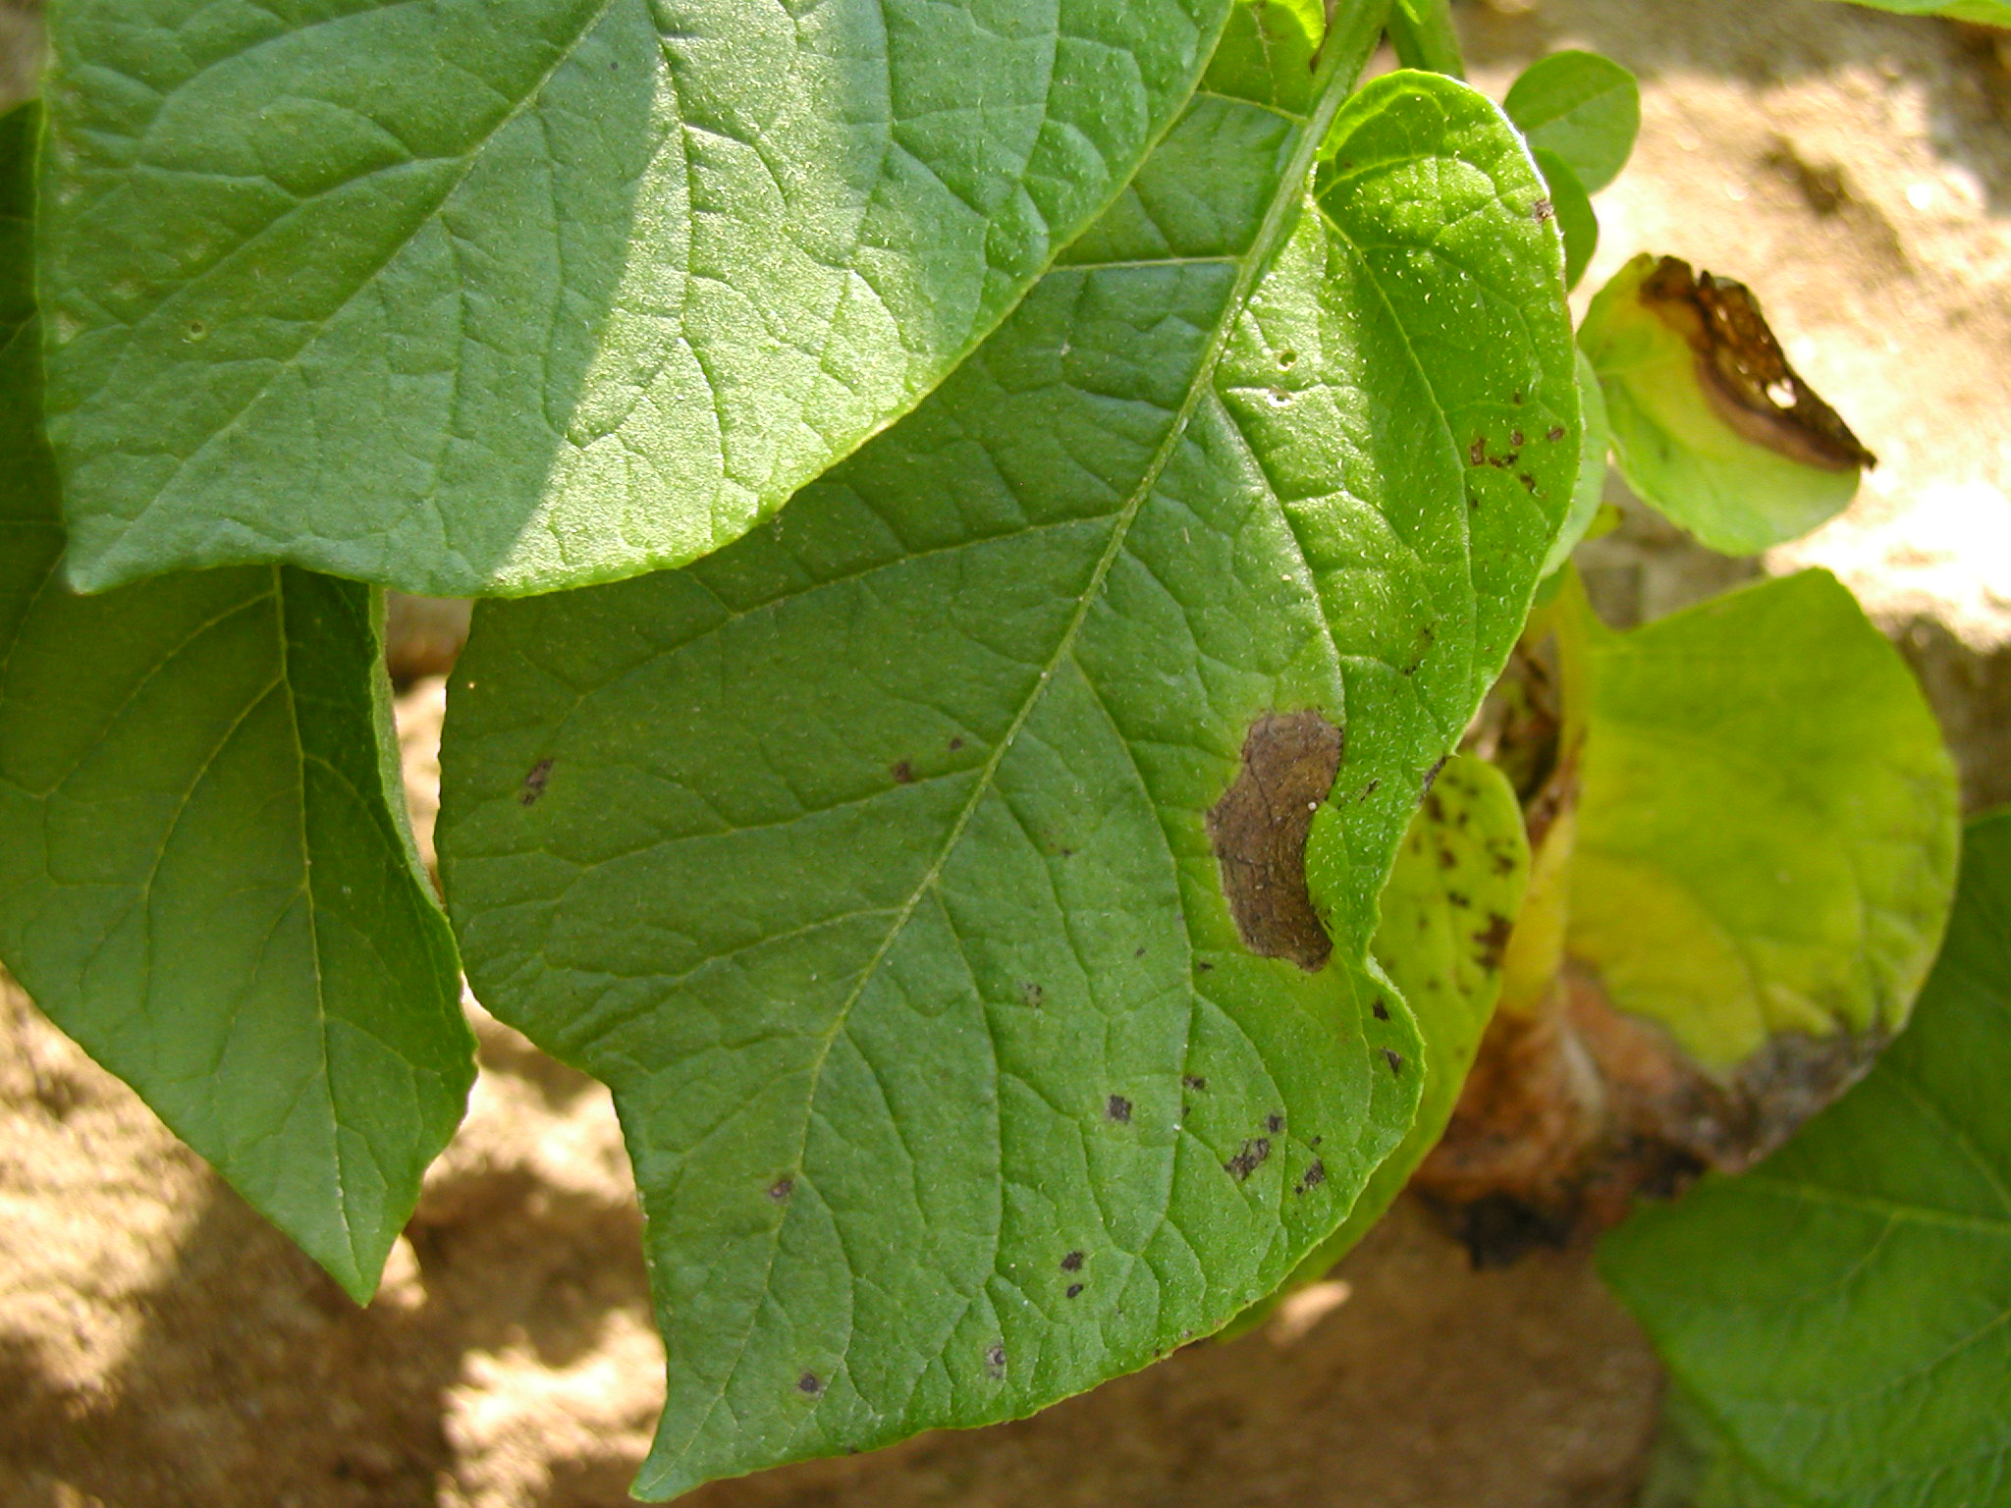

Figure 2.
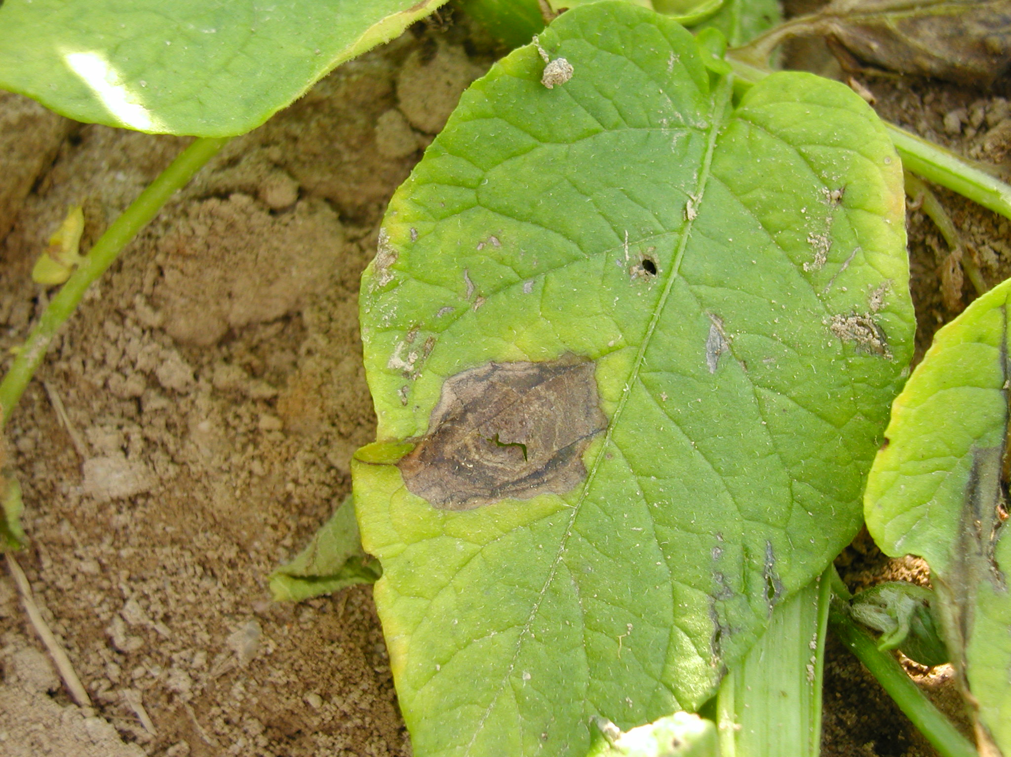

Figure 3.
