Virginia Potato Disease Advisory – 2013
Sponsored by the Virginia Irish Potato Board
May 10, 2013

This is the second Virginia Potato Disease Advisory for 2013. We want to thank the Virginia Irish Potato Board for funding the network of sensors and our weekly reports. Thanks to the VIPB and all the participating producers! In addition to our disease predictions, see below for a description of late blight of potato.

The wetter than normal conditions have been conducive for Late Blight Disease Severity Values (DSV) to accumulate. We have exceeded the threshold of 18 DSVs to trigger a preventative spray at the Horntown and Seaview locations. However, we have not received any reports of late blight in the region so far for 2013. You can track where late blight has been reported in the United States by visiting www.usablight.org. Currently, areas in Florida are the only locations reporting late blight. More rain is in our forecast for this weekend, thus, I would recommend a preventative fungicide application (such as mancozeb or chlorothalonil) at ALL locations on the Eastern Shore of Virginia. In addition, growers are urged to thoroughly scout their field for the disease. If you have any suspicious samples please let us know.

P-Day values for early blight development are NOT exceeding thresholds for fungicide treatment at all locations. At this time, no fungicide applications targeting early blight are recommended. Please check back next week for an updated report.

Late Blight Disease Severity Values (DSV) accumulated to date:
Location | Total DSV | Spray Recommendation
Horntown | 20 | Preventative Recommended
New Church | 15 | Preventative Recommended
Painter | 15 | Preventative Recommended
Birdsnest | 14 | Preventative Recommended
Seaview | 19 | Preventative Recommended
Kiptopeke | 14 | Preventative Recommended

Early Blight P-Days accumulated to date:
Location | Total P-Days | Spray Recommendation
Horntown | 136 | None Recommended
New Church | 134 | None Recommended
Painter | 146 | None Recommended
Birdsnest | 143 | None Recommended
Seaview | 150 | None Recommended
Kiptopeke | 153 | None Recommended

Weekly Potato Disease Summary

Late Blight of Potato

Causal Organism: Late blight of potato is caused by the airborne fungus (Oomycete) Phytophthora infestans. Late blight of potato is sporadic on the Eastern Shore of Virginia, but can be devastating if conditions favoring the disease persist. Trace amounts of late blight were observed on the Eastern Shore in 2011 and 2012, but the last significant outbreak was in 2009. Disease is favored by moderate temperatures (60-80F) with excessive rainfall or dews leading to high leaf moisture. Also of note, late blight of potato was the disease that caused the Irish Potato Famine in the 1840’s which led to the immigration or death of over 3 million Irish. The late blight pathogen can also parasitize tomatoes.

Symptomology: Infected potato leaves show ‘greasy’ lesions that usually originate from the tip of the leaves (Figures 1&3). During periods of high moisture gray sporulation can be seen on infected leaves. If infection persists or becomes systemic, tubers may become discolored exhibiting black and greasy lesions (Figure 2). Infected tubers may also transmit the disease to subsequent crops if they are used as seed pieces. In severe infections, complete defoliation can occur if appropriate disease control measures are not employed. Late blight reports in the USA can be monitored at www.usablight.org

Control: Use certified seed pieces to ensure that you are not transmitting late blight. Prior to disease appearance, growers should utilize a protectant fungicide (ie. chlorothalonil or mancozeb) once sprays are either deemed necessary by the VPDA or if the disease is present within the region. Once the disease is either present on the Eastern Shore, surrounding areas or within your fields, systemic fungicides should be used for disease suppression. Systemic fungicides recommended for late blight control include: Curzate, Forum, Gavel, Headline, Omega, Presidio, Previcur Flex, Quadris, Ranman, Revus Top, Revus and Tanos. For potato only, Super Tin or Agri Tin may also be utilized. As always, follow pesticide labels for rates and usage. Crop destruction is an option if disease is discovered in an isolated area (perhaps where the sprayer misses) or in its EARLY stages. Thorough scouting of potato fields for this disease cannot be emphasized strongly enough.

Figure 1.
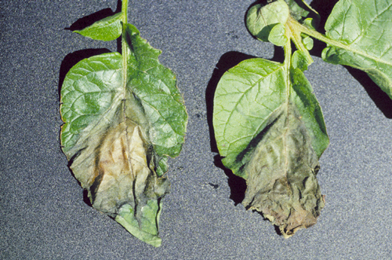

Figure 2.

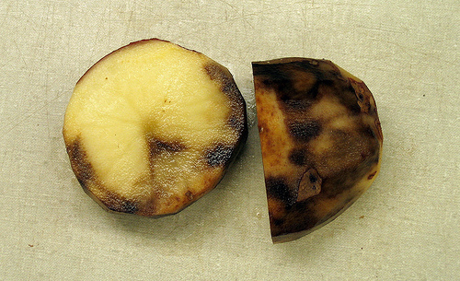

Figure 3.

