**Virginia Potato Disease Advisory – 2010**

**Sponsored by the Virginia Irish Potato Board**

**May 12**

This is the third Virginia Potato Disease Advisory for 2010. We want to thank the Virginia Irish Potato Board for funding the network of sensors and our weekly reports. Thanks to the VIPB and all the participating producers! It is our goal to make the Advisory more informative this year than in years past by highlighting important potato diseases or pertinent subject matters with each report. See below for a description of late blight of potato. As always, your feedback is important and welcomed on how to make the VPDA more informative and effective.

To date, recent conditions have not been conducive for disease development, therefore both Late Blight Disease Severity Values (DSV) have remained low. P-Days for early blight are creeping up but are not exceeding thresholds for fungicide treatment.

**Late Blight Prediction:** Fungicide applications should be initiated once 18 DSV’s have been accumulated for late blight. Thus, the threshold for late blight has not been reached at any of the locations. However, within the last week we have received a report of confirmed late blight infecting tomato plants in St. Mary's County, Maryland. It is possible that plants from this greenhouse were planted in Charles County, Maryland. These two counties are in close proximity to Virginia and our growers near these locations (Eastern Shore, Northern Neck, Northern Virginia) should be proactive in making fungicide applications that target late blight on both potato and tomato. Fortunately, our prevailing weather conditions across the eastern part of the Commonwealth have been nonconducive for late blight development. With this in mind, growers should enhance their scouting efforts for late blight and consider making applications of preventative fungicides at the very least. We will be sure to keep you up to date on this situation and will send an alert out should we find late blight in Virginia.

**Early Blight Prediction:** We use the program WISDOM to calculate P-Days, fungicide applications targeting early blight should be made when we reach 300 cumulative P-Days. To date, we have not reached this threshold at any location.

**Late Blight Disease Severity Values (DSV) accumulated to date:**

|  |  |  |
| --- | --- | --- |
| **Location** | **Total DSV** | **Spray Recommendation** |
| **Horntown** | **4** | ***See Comments Above*** |
| **New Church** | **4** | ***See Comments Above*** |
| **Painter** | **4** | ***See Comments Above*** |
| **Birdsnest** | **1** | ***See Comments Above*** |
| **Seaview** | **0** | ***See Comments Above*** |
| **Kiptopeke** | **2** | ***See Comments Above*** |

**Early Blight P-Days accumulated to date:**

|  |  |  |
| --- | --- | --- |
| **Location** | **Total P-Days** | **Spray Recommendation** |
| **Horntown** | **244** | **None Recommended** |
| **New Church** | **246** | **None Recommended** |
| **Painter** | **262** | **None Recommended** |
| **Birdsnest** | **261** | **None Recommended** |
| **Seaview** | **273** | **None Recommended** |
| **Kiptopeke** | **270** | **None Recommended** |

**Weekly Potato Disease Summary**

**Late Blight of Potato**

**Causal Organism:** Late blight of potato is caused by the airborne fungus (Oomycete) *Phytophthora infestans*. Late blight of potato is sporadic on the Eastern Shore of Virginia, but can be devastating if conditions favoring the disease persist. Trace amounts of late blight were observed on the Eastern Shore in 2006 and 2008, but the last significant outbreak was in 2009. Disease is favored by moderate temperatures (60-80F) with excessive rainfall or dews leading to high leaf moisture. Also of note, late blight of potato was the disease that caused the Irish Potato Famine in the 1840’s which led to the immigration or death of over 3 million Irish. The late blight pathogen can also parasitize tomatoes.

**Symptomology:** Infected potato leaves show ‘greasy’ lesions that usually originate from the tip of the leaves (Figures 1&3). During periods of high moisture gray sporulation can be seen on infected leaves. If infection persists or becomes systemic, tubers may become discolored exhibiting black and greasy lesions (Figure 2). Infected tubers may also transmit the disease to subsequent crops if they are used as seed pieces. In severe infections, complete defoliation can occur if appropriate disease control measures are not employed.

**Control:** Use certified seed pieces to ensure that you are not transmitting late blight. Prior to disease appearance, growers should utilize a protectant fungicide (ie. chlorothalonil or mancozeb) once sprays are either deemed necessary by the VPDA or if the disease is present within the region. Once the disease is either present on the Eastern Shore, surrounding areas or within your fields, systemic fungicides should be used for disease suppression. Systemic fungicides recommended for late blight control include: Curzate, Forum, Gavel, Headline, Omega, Presidio, Previcur Flex, Quadris, Ranman, Revus Top, Revus and Tanos. As always, follow pesticide labels for rates and usage.

**2009 Late Blight Outbreak:** The late blight outbreak of 2009 was the worst epidemic of the disease that we have experienced in about 20 years. Many factors contributed to this large scale outbreak, but conducive weather was certainly a key component. Last year we experienced a very cool and rainy spring and summer. The disease was first found on the Eastern Shore of Virginia on May 25th with recurring disease identifications on both potato and tomato throughout June and into the middle of July. The epidemic then slowed until Labor Day weekend when conditions became more favorable for disease development (ie. cooler temperatures and increased relative humidity). In addition to the weather driving the epidemic of 2009, a new genotype of late blight (US-23) was found on our tomato plantings. US-8 was also found on potato plants here on the Eastern Shore. The new genotype (US-23) shows increased affinity for tomato than does the ‘normal’ strain of late blight that we are used to observing (US-8). Fortunately, late blight cannot overwinter in our region without the presence of a host. However, due to the severity of the 2009 epidemic we will monitor this situation closely and pass along any information we can find on these weekly reports. If late blight is found in Virginia or surrounding states we will issues immediate alerts to you.

**Figure 1.**

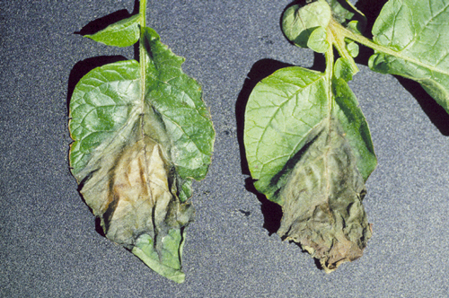

**Figure 2.**

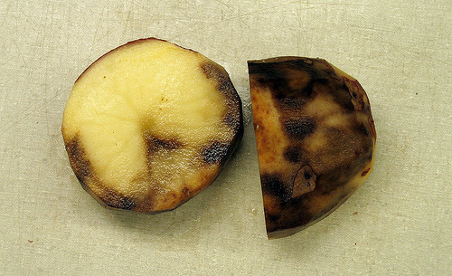

**Figure 3.**

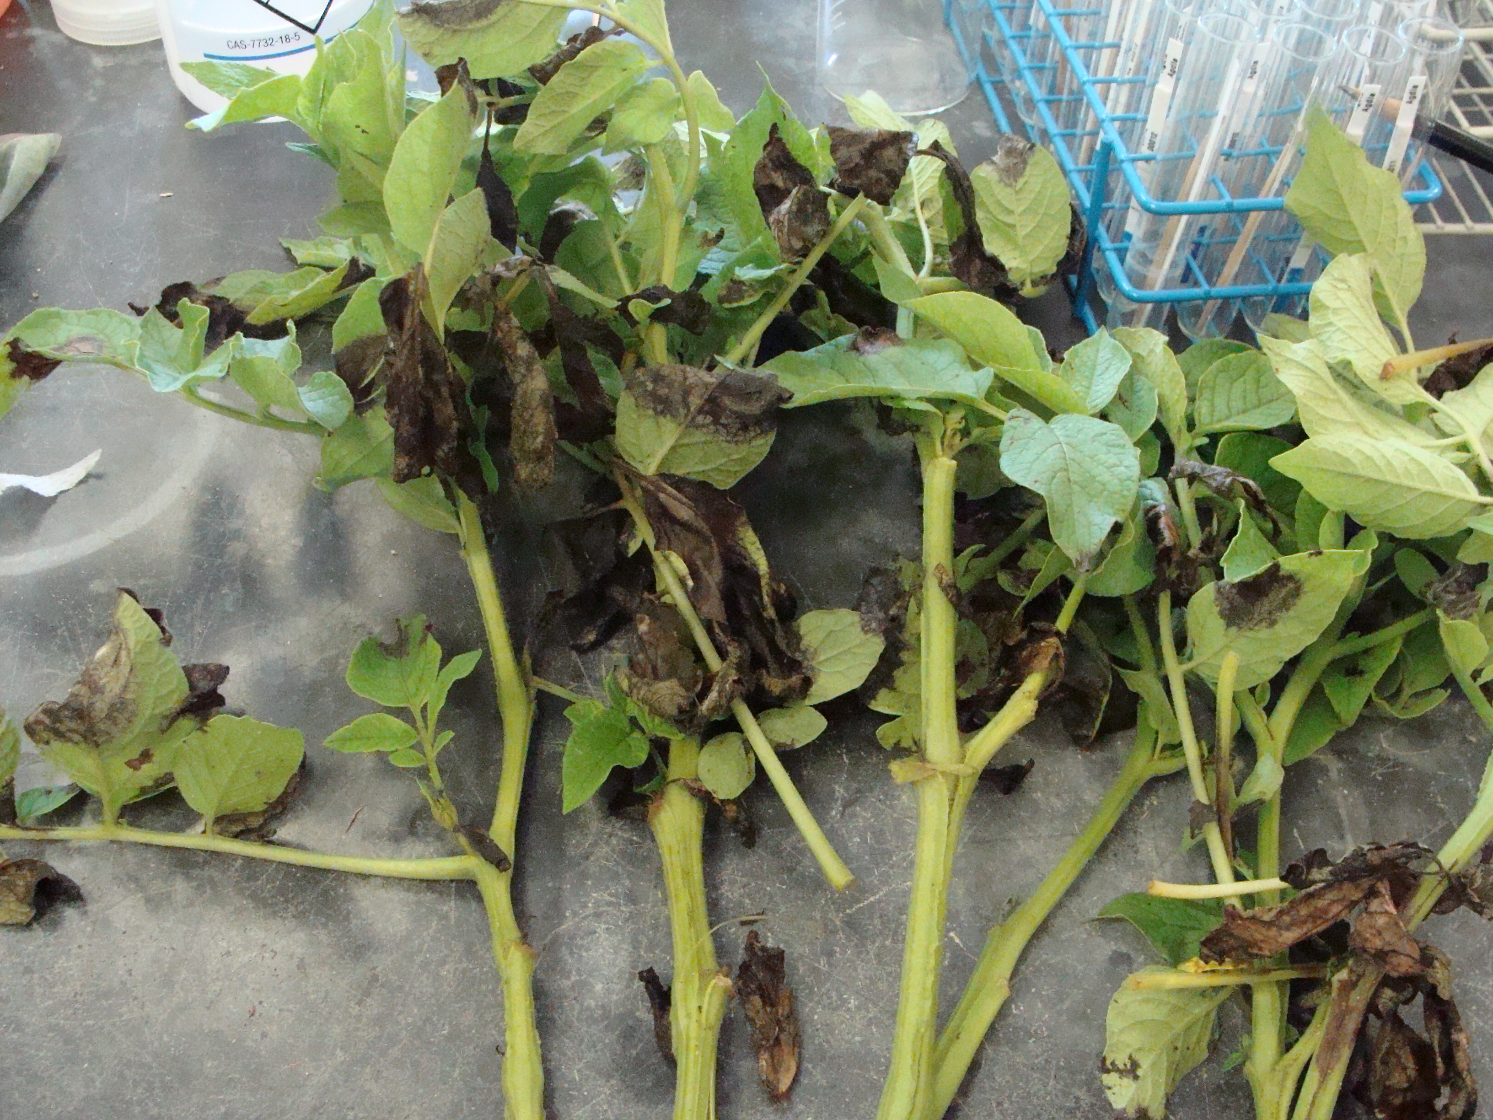

**If you have any questions please call: Bill Shockley – 757-414-0738 x 223 or**

**Steve Rideout 757-414-0724 x 17 or Christine Waldenmaier 757-414-0724 x 40**