Virginia Potato Disease Advisory – 2010
Sponsored by the Virginia Irish Potato Board
May 19

This is the fourth Virginia Potato Disease Advisory for 2010. We want to thank the Virginia Irish Potato Board for funding the network of sensors and our weekly reports. Thanks to the VIPB and all the participating producers! It is our goal to make the Advisory more informative this year than in years past by highlighting important potato diseases or pertinent subject matters with each report. See below for a description of early blight of potato. As always, your feedback is important and welcomed on how to make the VPDA more informative and effective.

To date, recent conditions have not been conducive for late blight development. Late Blight Disease Severity Values (DSV) have remained low. Early Blight P-Days have now exceeded our thresholds for fungicide applications.

Late Blight Prediction: Fungicide applications should be initiated once 18 DSV’s have been accumulated for late blight. To date we have not exceeded this threshold. However, late blight has been reported and is still present in St. Mary’s County, MD. Recent rainfall has been more conducive for disease development. Despite not exceeding threshold DSV’s, the proximity of late blight to our region coupled with more conducive conditions is cause for concern. Growers should consider making preventative applications (chlorothalonil or mancozeb) for late blight, particularly on the Eastern Shore and Northern Neck.

Early Blight Prediction: We use the program WISDOM to calculate P-Days, fungicide applications targeting early blight should be made when we reach 300 cumulative P-Days. We have exceeded this threshold at 5 of 6 locations, with the Horntown location being only 5 P-Days from this threshold. Fortunately, no early blight has been spotted on the Eastern Shore to date. Growers should consider preventative applications (chlorothalonil or mancozeb) at the very least to suppress levels of early and late blight that may be starting in their fields.

Late Blight Disease Severity Values (DSV) accumulated to date:

Location | Total DSV | Spray Recommendation
Horntown | 4 | See Above Recommendations
New Church | 4 | See Above Recommendations
Painter | 4 | See Above Recommendations
Birdsnest | 1 | See Above Recommendations
Seaview | 0 | See Above Recommendations
Kiptopeke | 2 | See Above Recommendations

Early Blight P-Days accumulated to date:
Location | Total P-Days | Spray Recommendation
Horntown | 295 | See Above Recommendations
New Church | 301 | See Above Recommendations
Painter | 312 | See Above Recommendations
Birdsnest | 313 | See Above Recommendations
Seaview | 328 | See Above Recommendations
Kiptopeke | 324 | See Above Recommendations

Weekly Potato Disease Summary
Early Blight of Potato
Causal Organism: Early blight of potato is caused by the fungus Alternaria solani. The fungus can overwinter in the soil on plant debris or on infected tubers. Early blight of potato occurs most years on the Eastern Shore of Virginia, generally late in the growing season when conditions favoring the disease persist. Plants that have entered the reproductive stages are more susceptible to early blight than those in vegetative stages. Disease is favored by moderate temperatures (75-80F) with rainfall or dews leading to high leaf moisture (humid). The early blight pathogen can also parasitize tomatoes and eggplants. The weeds horsenettle and nightshade are also hosts.

Symptomology: Infected potato leaves show ‘target spot’ lesions with concentric rings (Figure 1). These infections generally occur on the older leaves of the plant closest to the ground (Figure 2). Older lesions may exhibit a leathery appearance, however, the rings are the most characteristic symptom. Tuber infections show dark (brown-black) lesions that are small in size and irregular in shape, these tuber lesions generally are sunken in appearance (Figure 3). In severe infections, defoliation can occur if appropriate disease control measures are not employed.

Control: Use certified seed pieces to ensure that you are not transmitting early blight. Crop rotation with non hosts for at least 2 years will help reduce damage. Burying plant debris deep in the soil after harvest will help reduce inoculum in the soil. Certain cultivars have exhibited tolerance to early blight. Avoid overirrgation. Prior to disease appearance, growers should utilize a protectant fungicide (ie. chlorothalonil or mancozeb) once sprays are either deemed necessary by the VPDA. Systemic fungicides should be used for disease suppression once early blight has been discovered in your fields. Systemic fungicides recommended for early blight control include: Endura, Gem, Headline, Quadris, Reason, Revus Top, and Tanos. As always, follow pesticide labels for rates and usage.

Figure 1.
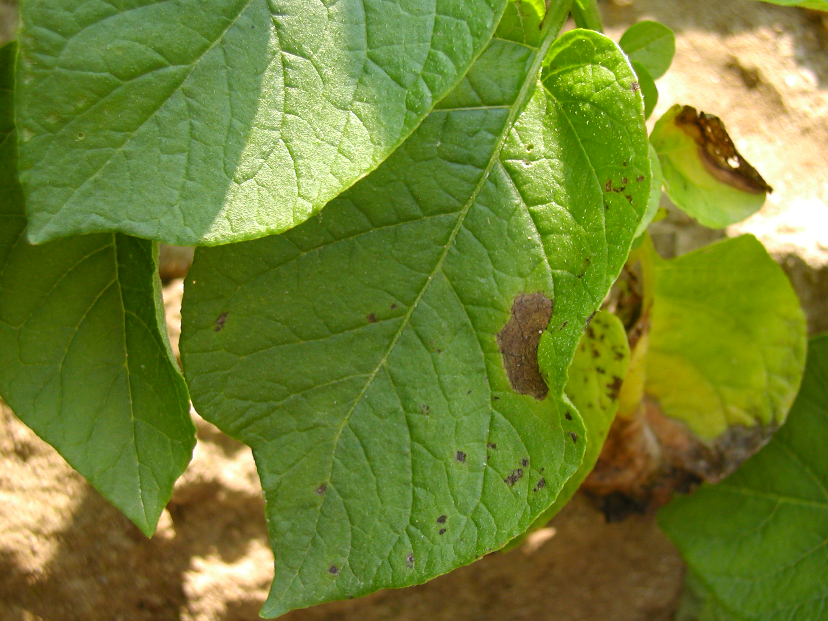

Figure 2.
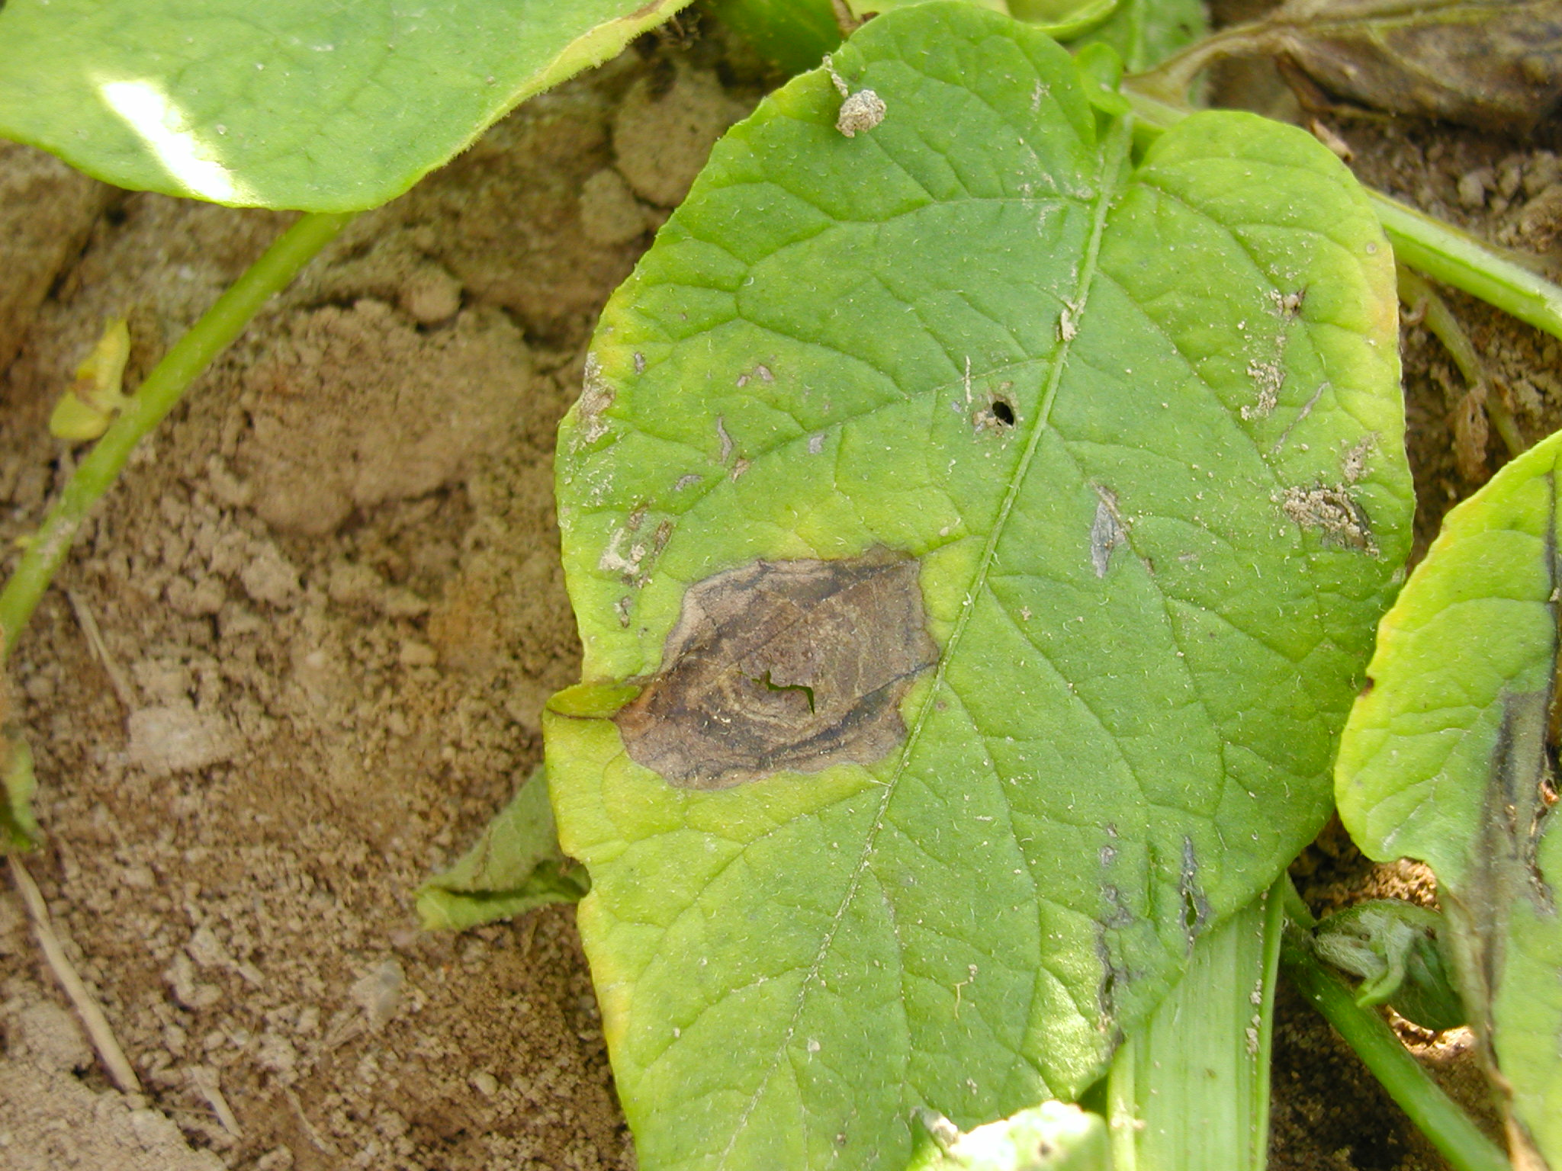

Figure 3.
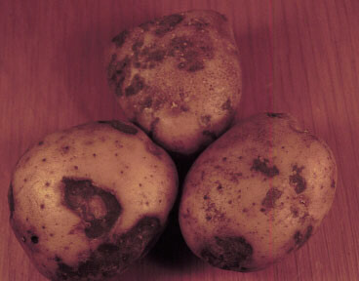

If you have any questions please call: Bill Shockley – 757-414-0738 x 223 or
Steve Rideout 757-414-0724 x 17 or Christine Waldenmaier 757-414-0724 x 40

