Virginia Potato Disease Advisory – 2010
Sponsored by the Virginia Irish Potato Board
May 26

This is the fifth Virginia Potato Disease Advisory for 2010. We want to thank the Virginia Irish Potato Board for funding the network of sensors and our weekly reports. Thanks to the VIPB and all the participating producers! It is our goal to make the Advisory more informative this year than in years past by highlighting important potato diseases or pertinent subject matters with each report. See below for a description of damage caused by Rhizoctonia of potato. As always, your feedback is important and welcomed on how to make the VPDA more informative and effective.

In all locations, Late Blight Disease Severity Values (DSV) accumulated quickly this week due to recent rainfall and moist conditions. Early Blight P-Days have now exceeded our thresholds for fungicide applications and continue to accumulate.

Late Blight Prediction: Fungicide applications should be initiated once 18 DSV’s have been accumulated for late blight. To date we have not exceeded this threshold. However, late blight has been reported and is still present in St. Mary’s County, MD. An additional report has now come from NW Pennsylvania. This is not as eminent of a threat as the Maryland location due to location. Recent rainfall has been more conducive for disease development. Despite not exceeding threshold DSV’s, the proximity of late blight to our region coupled with more conducive conditions is cause for concern. Growers should consider making preventative applications (chlorothalonil or mancozeb) for late blight, particularly on the Eastern Shore and Northern Neck if they have not already done so.

Early Blight Prediction: We use the program WISDOM to calculate P-Days, fungicide applications targeting early blight should be made when we reach 300 cumulative P-Days. We have exceeded this threshold at all 6 locations. Fortunately, no early blight has been spotted to date. Growers should consider preventative applications (chlorothalonil or mancozeb) at the very least to suppress levels of early and late blight that may be starting in their fields.

Late Blight Disease Severity Values (DSV) accumulated to date:
Location | Total DSV | Spray Recommendation
Horntown | 10 | See Above Recommendations
New Church | 11 | See Above Recommendations
Painter | 16 | See Above Recommendations
Birdsnest | 12 | See Above Recommendations
Seaview | 14 | See Above Recommendations
Kiptopeke | 12 | See Above Recommendations

Early Blight P-Days accumulated to date:
Location | Total P-Days | Spray Recommendation
Horntown | 374 | See Above Recommendations
New Church | 373 | See Above Recommendations
Painter | 393 | See Above Recommendations
Birdsnest | 384 | See Above Recommendations
Seaview | 403 | See Above Recommendations
Kiptopeke | 399 | See Above Recommendations

Weekly Potato Disease Summary
Rhizoctonia of Potato
Causal Organism: Rhizoctonia of potato is caused by the soilborne fungus Rhizoctonia solani. The fungus can overwinter in the soil on plant debris or on infected tubers. The pathogen can be an issue from planting until harvest. Seed pieces and emerging stolons may be infected by Rhizoctonia prior to emergence. Damping-off can be caused on emerged seedlings under severe infections and favorable conditions. Tubers and stolons can be damaged by the pathogen later in the growing season. Disease is favored by moderate soil temperatures (50 - 70F) with excessive rainfall or irrigation. The fungus can infect and damage most crop plants planted on the Eastern Shore of Virginia, particularly in the seedling stage.

Symptomology: Poor and non-uniform emergence can result from early infections. Infected potato shoots can be girdled at the soil surface and exhibit a sunken blackish lesion (Figure 1). Similar lesions can be found belowground on stolons later in the growing season, this phase of the disease is known as black scurf (Figure 2). Starch and water translocation can be disturbed in these damaged plants. An increase of aerial, green tubers forming at/above the soil surface has been observed in infected plants. Infected tubers show dark brown-black masses that are small in size, these tuber lesions are actually sclerotia of the fungus attacked to the tuber surface (Figure 3). These masses resemble soil particles clinging to the tuber, however, they cannot be removed with washing.

Control: Use certified seed pieces to ensure that you are not transmitting Rhizoctonia. Burying plant debris deep in the soil after harvest will help reduce inoculum in the soil. Crop rotation to corn, cereal or grass crops will help reduce disease levels. Avoid overirrgation and planting in areas that stay wet. Promote timely emergence, the longer the shoots are in the soil the more susceptible they are to this pathogen. The use of an in-furrow application of Quadris or Moncut will reduce early season infections and ensure a quicker emergence. As always, follow pesticide labels for rates and usage. Finally, harvesting tubers in a timely fashion after vine kill will reduce the possibility of further tuber damage.

Figure 1.
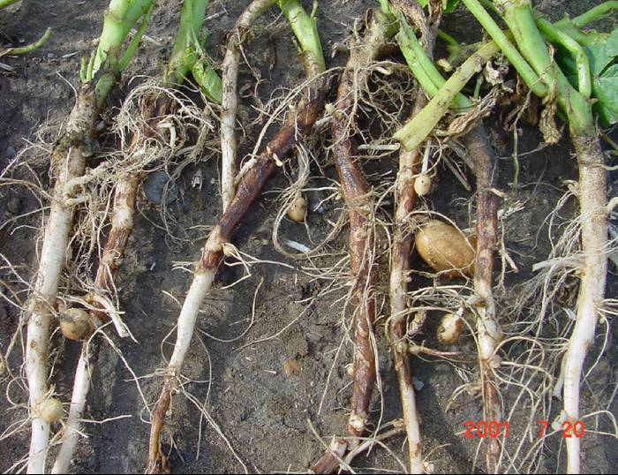

Figure 2.
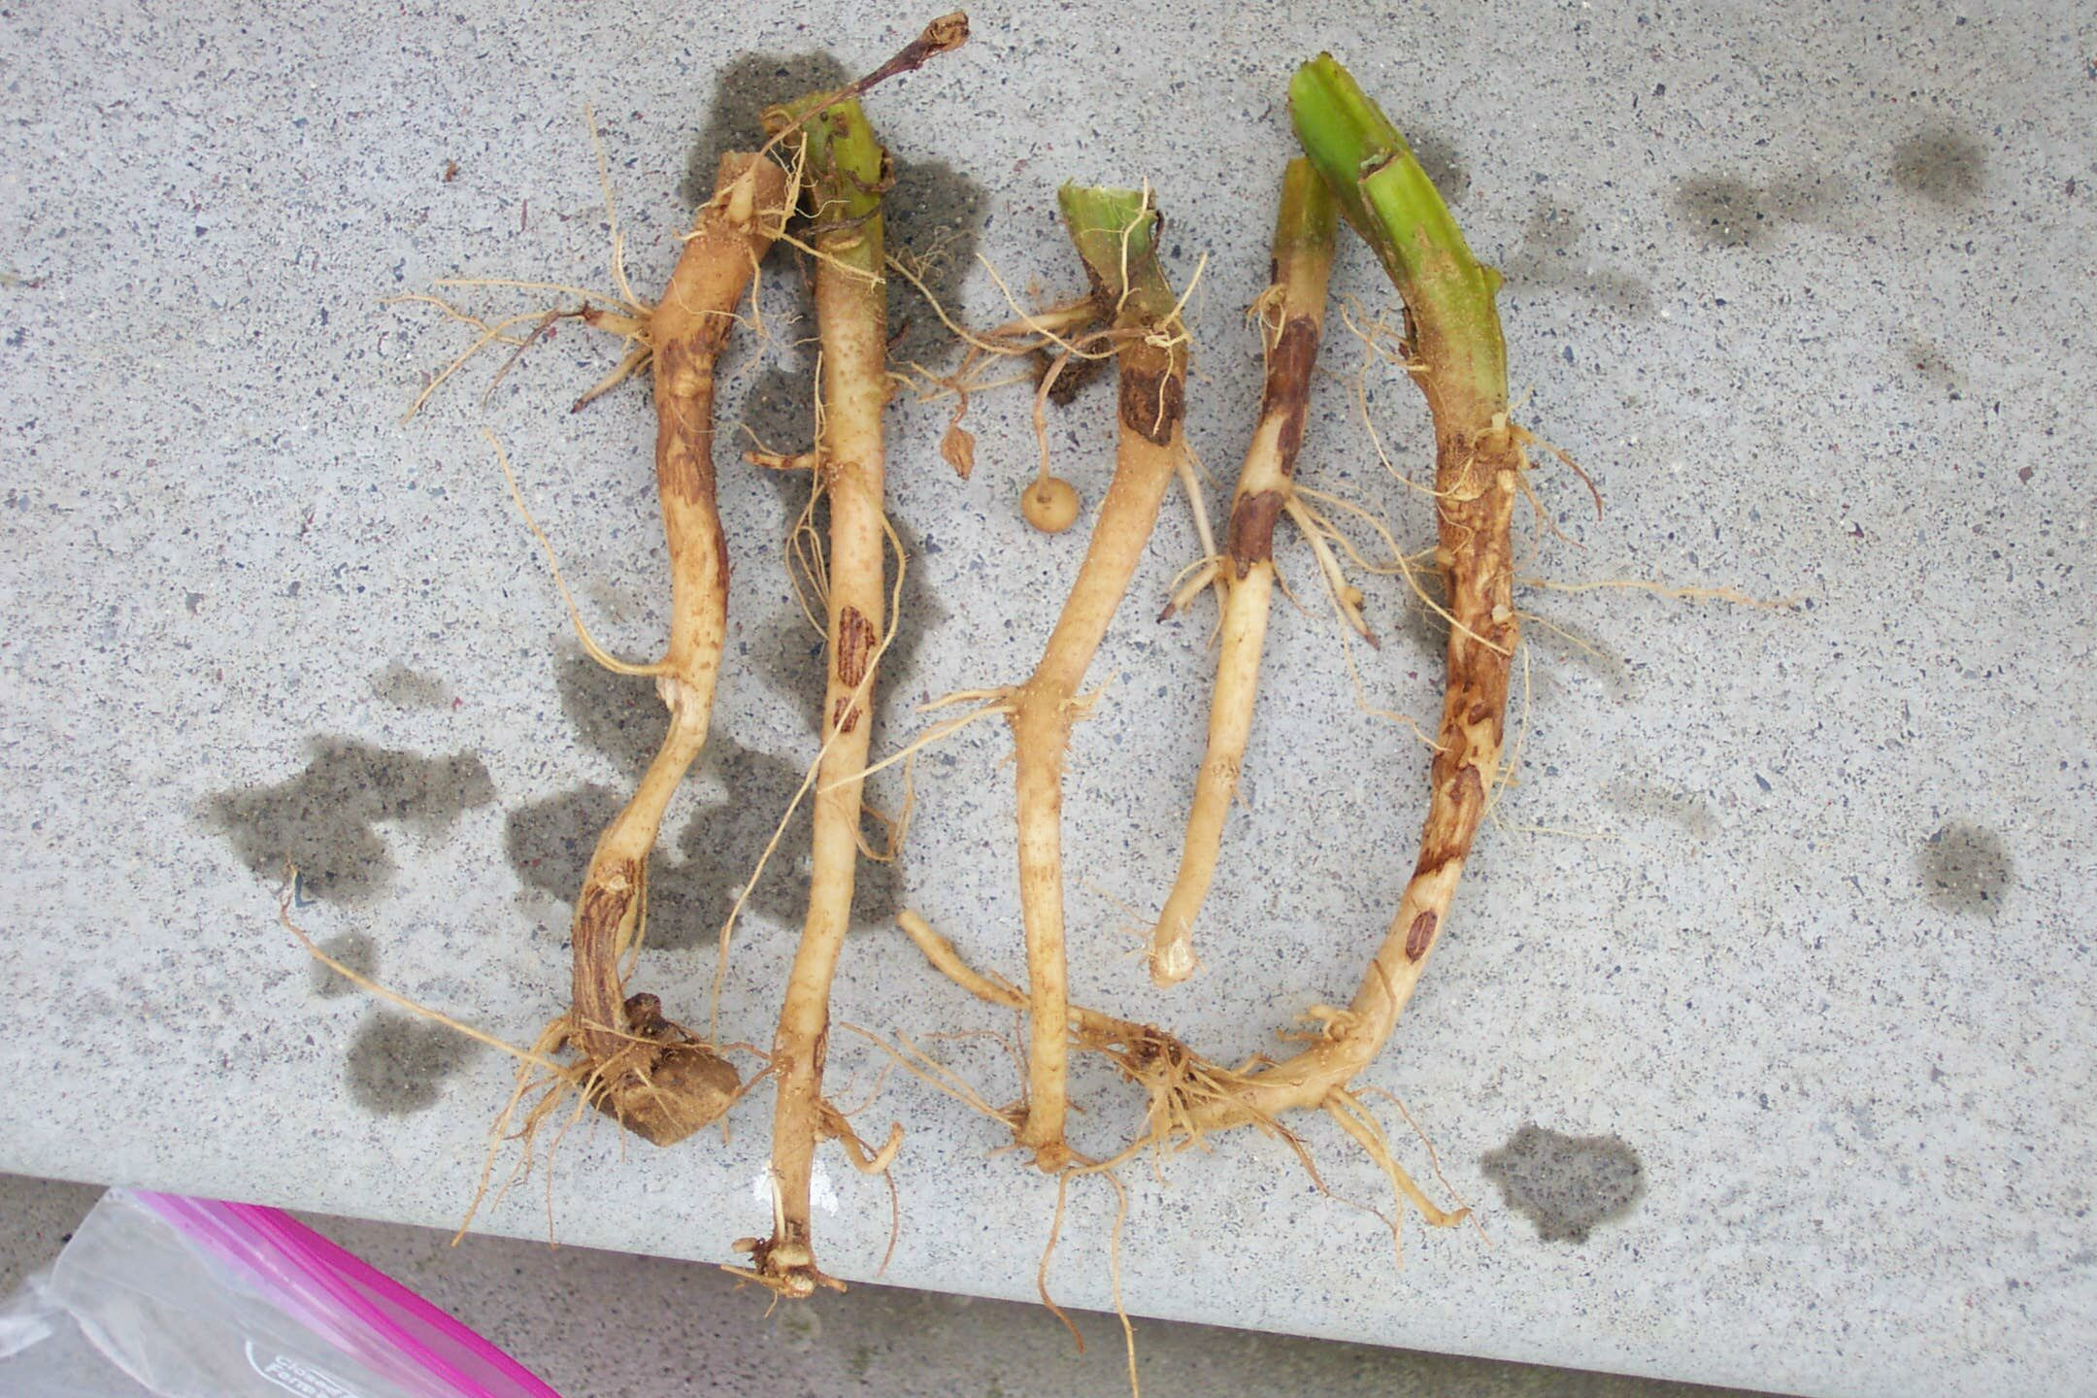

Figure 3.
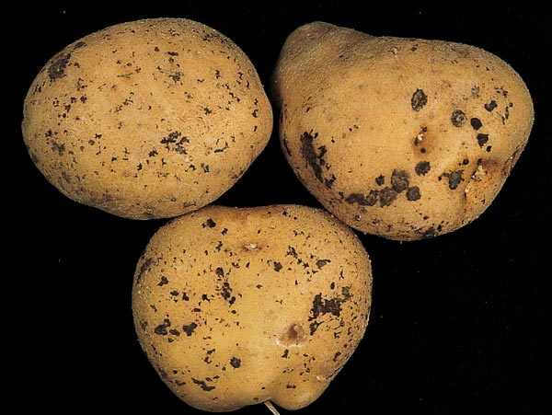

If you have any questions please call: Bill Shockley – 757-414-0738 x 223 or
Steve Rideout 757-414-0724 x 17 or Christine Waldenmaier 757-414-0724 x 40

