Virginia Potato Disease Advisory – 2011
Sponsored by the Virginia Irish Potato Board
May 6

This is the second Virginia Potato Disease Advisory for 2011. We want to thank the Virginia Irish Potato Board for funding the network of sensors and our weekly reports. Thanks to the VIPB and all the participating producers! In addition to our disease predictions, see below for a description of early blight of potato. As always, your feedback is important and welcomed on how to make the VPDA more informative and effective.

To date, recent conditions have not been conducive for disease development, therefore both Late Blight Disease Severity Values (DSV) and Early Blight P-Days have remained low. Values are not exceeding thresholds for fungicide treatment. At this current time, fungicide applications targeting late and early blight are unwarranted.

Late Blight Prediction: Fungicide applications should be initiated once 18 DSV’s have been accumulated for late blight. Thus, the threshold for late blight has not been reached at any of the locations. In addition, late blight has not been reported in the Mid-Atlantic Region to date. There was a report of late blight two weeks ago in a greenhouse structure on tomato transplants and potato plants in Connecticut, however, this does not constitute a major threat to our area at this time. We will continue to monitor this situation and alert you of any other reports that may occur within our region.

Early Blight Prediction: We use the program WISDOM to calculate P-Days, fungicide applications targeting early blight should be made when we reach 300 cumulative P-Days. To date, we have not reached this threshold at any location.

Late Blight Disease Severity Values (DSV) accumulated to date:

Location | Total DSV | Spray Recommendation
Horntown | 3 | None Recommended
New Church | 3 | None Recommended
Painter | 9 | None Recommended
Birdsnest | 4 | None Recommended
Seaview | 2 | None Recommended
Kiptopeke | 2 | None Recommended

Early Blight P-Days accumulated to date:
Location | Total P-Days | Spray Recommendation
Horntown | 182 | None Recommended
New Church | 182 | None Recommended
Painter | 187 | None Recommended
Birdsnest | 186 | None Recommended
Seaview | 198 | None Recommended
Kiptopeke | 221 | None Recommended

Weekly Potato Disease Summary
Early Blight of Potato
Causal Organism: Early blight of potato is caused by the fungus Alternaria solani. The fungus can overwinter in the soil on plant debris or on infected tubers. Early blight of potato occurs most years on the Eastern Shore of Virginia, generally late in the growing season when conditions favoring the disease persist. Plants that have entered the reproductive stages are more susceptible to early blight than those in vegetative stages. Disease is favored by moderate temperatures (75-80F) with rainfall or dews leading to high leaf moisture (humid). The early blight pathogen can also parasitize tomatoes and eggplants. The weeds horsenettle and nightshade are also hosts.

Symptomology: Infected potato leaves show ‘target spot’ lesions with concentric rings (Figure 1). These infections generally occur on the older leaves of the plant closest to the ground (Figure 2). Older lesions may exhibit a leathery appearance, however, the rings are the most characteristic symptom. Tuber infections show dark (brown-black) lesions that are small in size and irregular in shape, these tuber lesions generally are sunken in appearance (Figure 3). In severe infections, defoliation can occur if appropriate disease control measures are not employed.

Control: Use certified seed pieces to ensure that you are not transmitting early blight. Crop rotation with non hosts for at least 2 years will help reduce damage. Burying plant debris deep in the soil after harvest will help reduce inoculum in the soil. Certain cultivars have exhibited tolerance to early blight. Avoid overirrgation. Prior to disease appearance, growers should utilize a protectant fungicide (ie. chlorothalonil or mancozeb) once sprays are either deemed necessary by the VPDA. Systemic fungicides should be used for disease suppression once early blight has been discovered in your fields. Systemic fungicides recommended for early blight control include: Endura, Gem, Headline, Quadris, Reason, Revus Top, and Tanos. As always, follow pesticide labels for rates and usage. Do not rely solely on QoI (Strobilurin) fungicides (Headline, Quadris and Tanos) for control of early blight. Our fungicides trials in 2010 on both potato and tomato indicated that these materials have reduced efficacy when applied alone. Please be sure to rotate or tank mix these materials with fungicides possessing a different mode of action.

Figure 1.
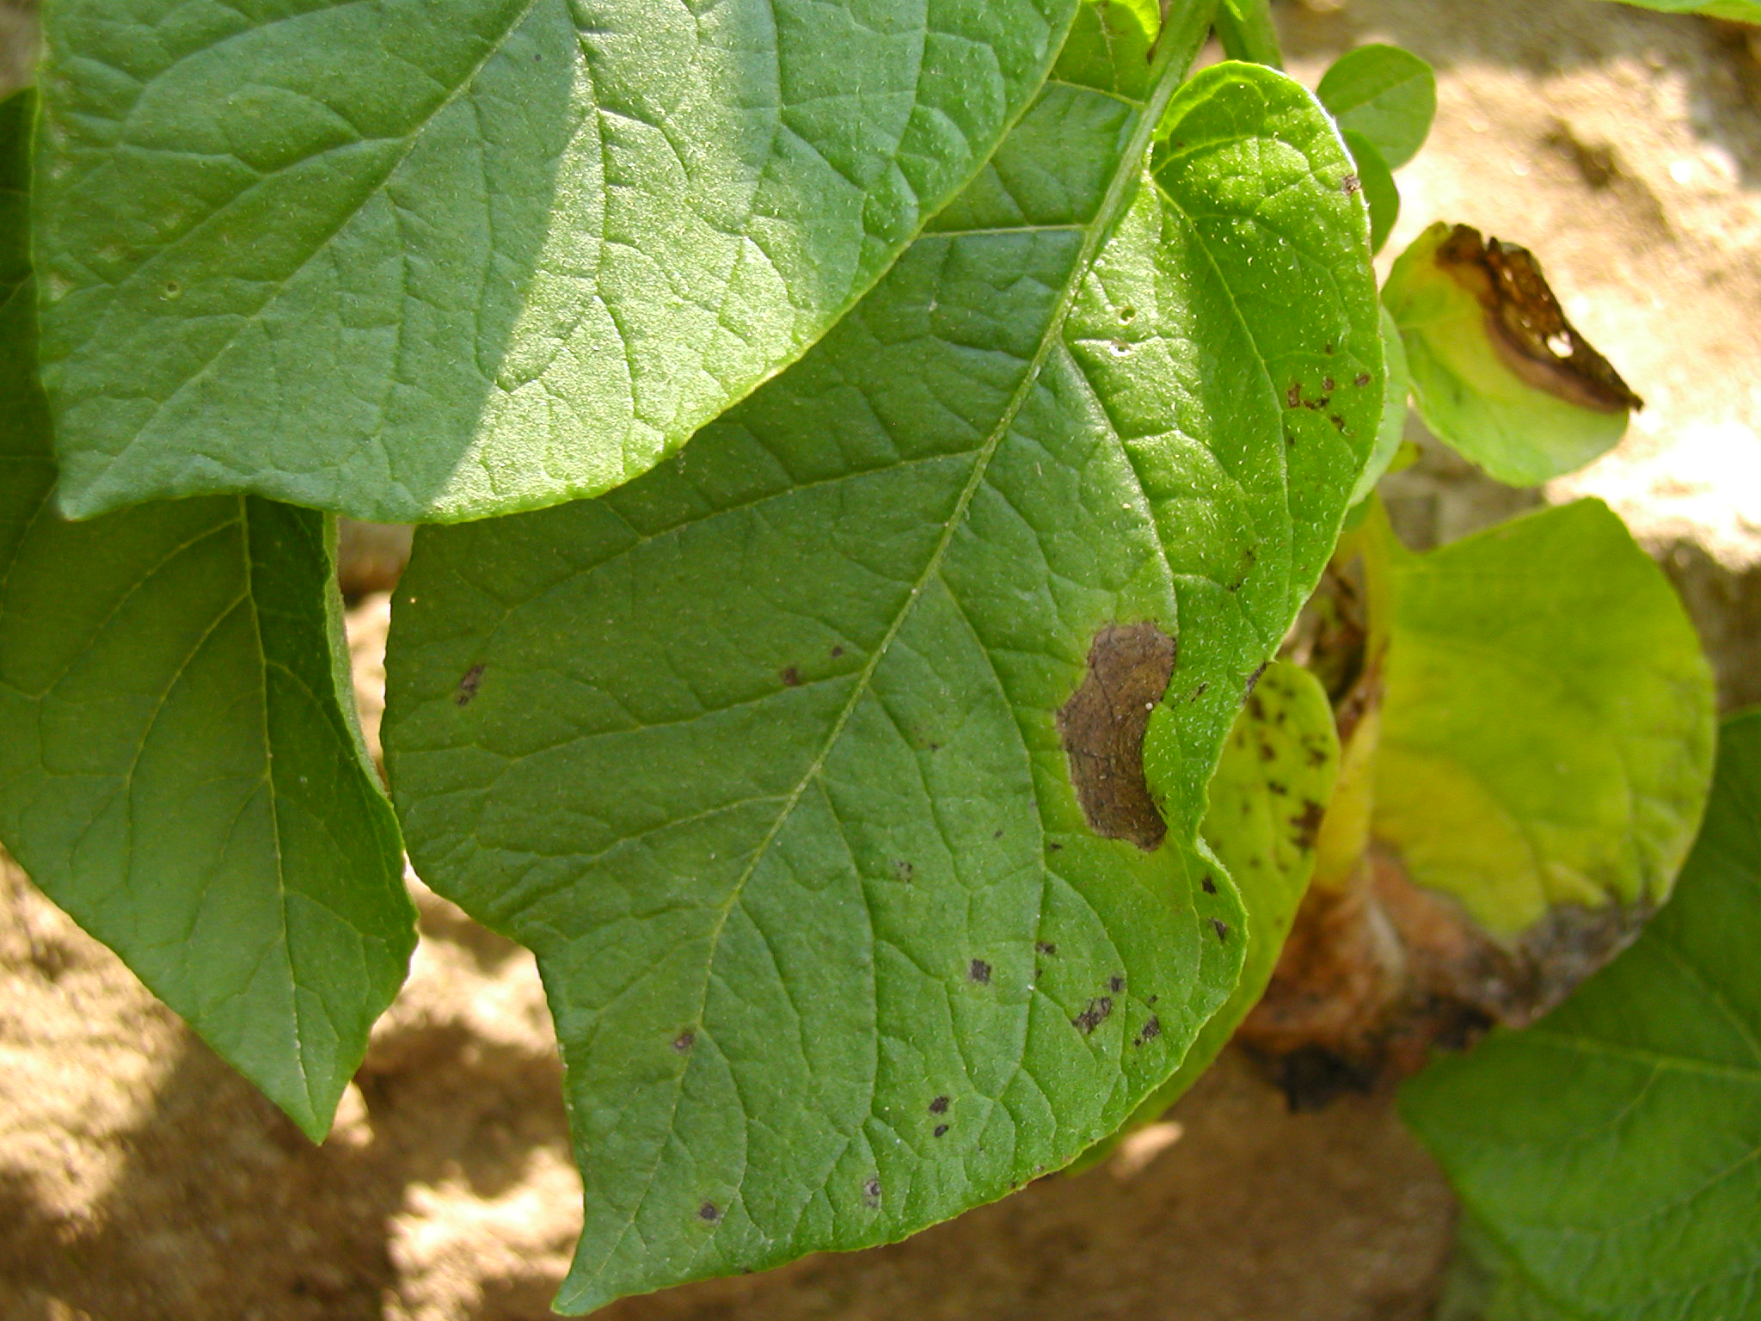

Figure 2.
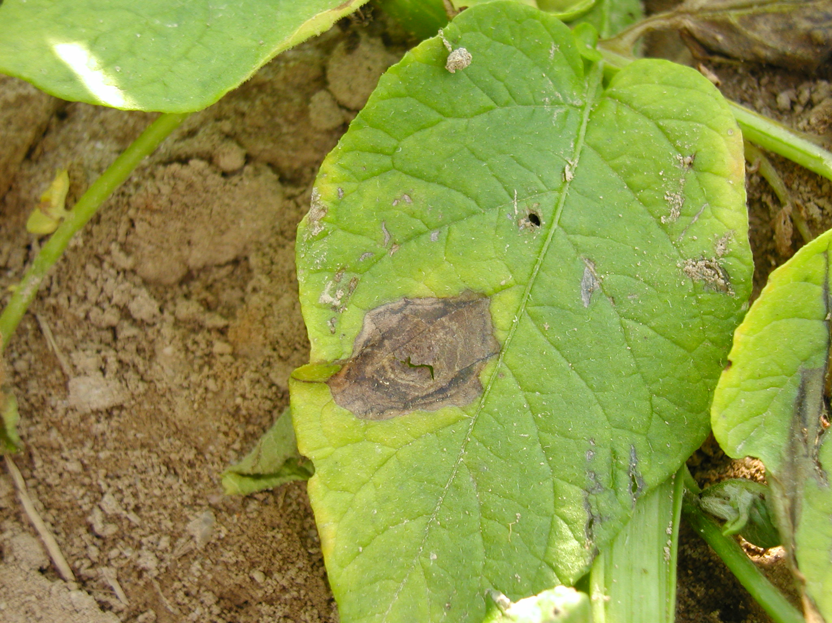

Figure 3.
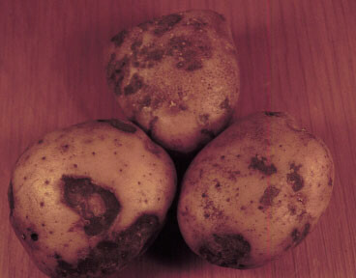

If you have any questions please call: Bill Shockley – 757-678-7945 or
Steve Rideout 757-414-0724 x 17 or Christine Waldenmaier 757-414-0724 x 40

