Late Blight on Potato Found on Eastern Shore of Virginia; Cucurbit Downy Mildew Widespread on Cucumber in North Carolina

Potato Late Blight - Late blight is a historic disease that was responsible for the great Irish Potato Famine in the 1840’s. This fungal disease is favored by moist conditions. We have received reports from North Carolina, New Jersey, New York and recently Pennsylvania indicating confirmed late blight on potato and tomato This week we confirmed late blight on potato here on the Eastern Shore of Virginia. To date, this is an isolated event, with only one infected leaf being found on a potato field near Saxis, VA. We are in the process of sending this isolate off to gather further information about the strain that is present.

Commercial potato and tomato growers are urged to diligently scout for late blight (Figure 1) and make applications of materials specific for late blight. Previous research has indicated that Curzate, Forum, Gavel, Presidio, Previcur Flex, Ranman, Reason, Revus Top, and Tanos are the most effective options. Also, remember to include a protectant material (containing either chlorothalonil or mancozeb) in your spray mixture. In potato, Omega and Agri-Tin/Super Tin are also available options.

This disease presents a challenge to homeowners and gardeners. Most fungicides at stores will contain the active ingredient chlorothalonil. This is the most active choice for home gardens. You will need to spray every 3-5 days if these conditions persist. If you have late blight and do not spray, unfortunately, your plants will most likely perish. Untreated plants will also serve as inoculum for your uninfected tomato or potato plants and for your neighbor’s garden as well. We will keep you up to date on the progress of this potentially devastating disease.

Cucurbit Downy Mildew - Cucurbit downy mildew (CDM) has been reported in several counties on cucumbers in North Carolina recently. The disease has been reported as far north as Franklin and Nash Counties, NC. In addition, an isolated outbreak of CDM on cucumber was reported in Gloucester County, New Jersey (not Virginia). To keep track of where downy mildew has been reported please visit the following website: http://cdm.ipmpipe.org/

Cucurbit growers are urged to consider spraying preventative applications for downy mildew and thoroughly scout for the disease. Cucumber growers in particular are strongly recommended to initiate a downy mildew protection program. Growers near the outbreak are advised to be particularly diligent for management and scouting of the disease.

Over the past growing seasons, our research has found spray programs containing Ranman (2.75 floz/A) to offer the best protection from this disease. Presidio (4 floz/A) and Previcur Flex (1.2 pt/A) are also effective, however, we caution growers to not rely upon these materials solely as our trial results from 2009 – 2011 for Previcur Flex and 2011 for Presidio were not as favorable as in past seasons in our cucumber CDM trials. These materials should be rotated/tank mixed with protectant fungicides containing mancozeb or chlorothalonil. Fungicide applications should be initiated prior to disease development and applied on a 7-10 day schedule. Growers will realize optimal disease control when applications are made in at least 20 GPA of water and crop coverage is good. Cultural practices, such as avoiding low lying fields and excessive overhead irrigation, will also suppress disease development. There are some differences in the susceptibility of cucumber cultivars to CDM. If you have any questions along those lines, please feel free to contact us.

Cucurbit downy mildew can be recognized initially by small yellow spots on the upper surface of the lower leaves (Figure 2). When humidity is high (particularly early in the morning) blue/gray sporulation can be found on the underside of the leaves (Figure 3). If you have any further questions or think you have cucurbit downy mildew present in your field, please let us know. We will continue to update you on the progress of this disease.

Steve Rideout, Ph.D.
Assistant Professor of Plant Pathology
Virginia Tech – Eastern Shore AREC
Painter, VA
(757) 414-0724; ext. 17
srideout@vt.edu
FACEBOOK: www.facebook.com/vtesarecpp

Figure 1.
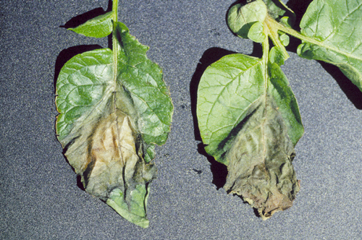

Figure 2.

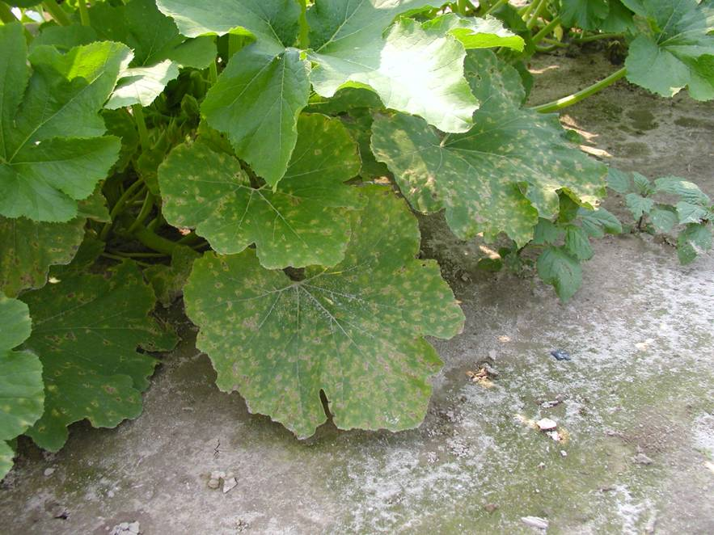

Figure 3.

